Scent Specific Man Trailing for Patrol Dog- Basic Course
October 13-15, 2025
Hosted by City of Dubuque Police Department
Iowa
The 3 Day BASIC course will provide handlers the opportunity to learn their Patrol Dog’s true capabilities. Handlers will be assisted in reading their dogs in and out of odor “negatives”. Conduct tracks on hard surface, 24-hour old track, and thru high pedestrian traffic - demonstrating the dog’s ability to scent discriminate. Teams will be provided best practices on how to obtain scent from a scene, sample training logs, sample reports, and a component list of tracks applicable to their patrol response.
Class size is limited for an optimal K9 Team to Instructor ratio and allows for teams to conduct multiple tracks each day. Class will start at 9:30 am on Monday October 13, 2025. Location will be at 4928 Public Safety Way, Dubuque Iowa.
To register for class and or hotel information - contact Dubuque Police Lt Kane Hoffman at kahoffma@cityofdubuque.org or by cell (608) 732-3562.
Course cost is $500.00 per K9 team. Prepay by mailing a check to Canine Search Solutions LLC 7965 Goldfield Road, Pound Wi 54161. A W9 or invoice is available by emailing coren0120@gmail.com or by calling Carren at 608-692-5001. To pay by credit card utilize the above information for making contact. (an additional processing fee).
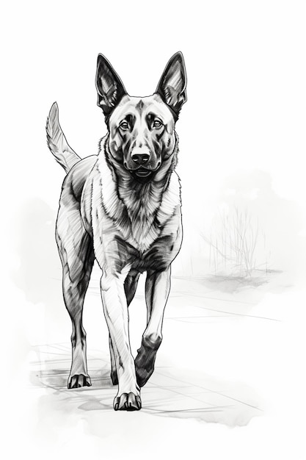CanineSearchSolutionsLLC

