Scent Specific Trailing for Patrol Dog I
taught by Canine Search Solutions LLC
May 11-13, 2026
hosted by Calumet County Sheriff Office
Wisconsin
The 3 Day BASIC course will provide handlers the opportunity to learn their Patrol Dog’s true capabilities. Handlers will be assisted in reading their dogs in and out of odor “negatives”. Conduct tracks on hard surface, 24-hour old track, and through high pedestrian traffic demonstrating the dog’s ability to scent discriminate. Teams will be provided best practices on how to obtain scent from a scene, sample training logs, sample reports, and a component list of tracks applicable to their patrol response.
Class size is limited for an optimal K9 team to Instructor ratio and allows for teams to conduct multiple tracks each day. Class will start at 9:30 am on May 11th at the Calumet County Sheriff Office located at 206 Court Street Chilton Wisconsin.
To register for class and or hotel information - contact Calumet County Sheriff K9 Handler Kenneth Matuszak by email Kenneth.Matuszak@calumetcounty.org or 1(920)629-0318.
Course cost is $500.00 per K9 team. Prepay by mailing a check to Canine Search Solutions LLC 7965 Goldfield Road, Pound Wi 54161. A W9 or invoice is available by emailing coren0120@gmail.com or by calling Carren at 608-692-5001. To pay by credit card utilize the above information for making contact. (an additional processing fees).

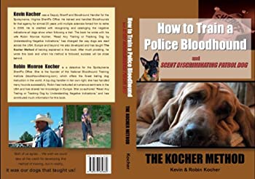


Calumet County Sheriff Office
ATTN: Kenneth Matuszak

Agency Name: Click or tap here to enter text.
Contact Person/Email/Phone #: Click or tap here to enter text.
K9 Handler Name/Email/ Phone #: Click or tap here to enter text.
K9 Name: Click or tap here to enter text.

Lodging

Best Western
1101 E Chestnut
Chilton Wi

Cobblestone Inn
800 W Ryan St
Brillion Wi

